

**Batch: B-2 Roll No.: 16010422234 Experiment No.: 8**

**______________________________________________________________________________**

**Aim:** To create wireframe for Mobile UI – Page Composition

**______________________________________________________________________________**

**Resources needed:** Wireframing tool

**Theory:**

The composition is a process of assembling a layout that consistently arranges components and content on a page. These rules were repeated on all other pages, creating a recognizable system of component relationships that were understood by social reading norms.

Using templates is essential in mobile design. Designers want to create layouts based on cultural norms of reading conventions and how people process information.

The templates that are used across a product, on most every page of a website or application, are called a wrapper because they enclose (wrap around) all the other components and the content. Considering design from the wrapper down allows:

* The designer to organize information within a consistent template across the OS
* Information to be organized hierarchically on a page
* The user to identify the organization structure, quickly increasing learnability while decreasing performance error

Patterns for Composition

Using appropriate and consistent wrappers will create mappings and affordances that will allow for positive user experiences.

* Scroll

When information on a page exceeds the viewport, a scroll bar control may be required to access the additional information. Scrolling of information should almost always occur along one axis.

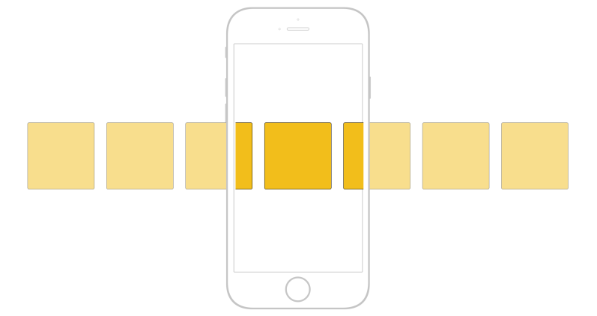

Figure : Horizontal Scroll bar

Scroll is especially relevant to the list and list-like Display of Information patterns:

* Vertical List
  + Infinite List
  + Thumbnail List
  + Select List
* Infinite List
* Thumbnail List
* Fisheye List
* Carousel
* Grid
* Film Strip
* Annunciator Row

This displays the status of hardware features on the top of each page. The status of functions that may be displayed is radios, input and output features, and power levels.

* Notifications

When an alert requires user attention, a notification will occur in some form of visual, haptic, or audible feedback. These notification displays must allow for user interaction.

* Titles

Pages, content, and elements that require labels should use titles. These titles should be horizontal, be consistent in style, and follow guidelines of legibility and readability.

* Revealable Menu

This type of menu displays additional menus that are not immediately apparent. A gesture, soft key, or on-screen selection will cause these menus to immediately display on-screen.

* Fixed Menu

This type of menu presents an always-visible menu or control that is docked to one side of the viewport. This menu is consistently placed throughout the application. These interactive controls are most likely icons with textual coding.

* Home & Idle Screens

These screens are used as display states when either a device is turned on or an application has exited, timed out, or returned to a device-level menu display.

* Lock Screen

Mobile devices use this display state to save on power consumption. When necessary, the application’s sleep state may become locked to protect the security of the data the user has input.

* Interstitial Screen

This type of screen is used primarily as a loading process screen during device or application startup. Wait indicators may be used to show loading progress.

* Advertising

When advertising is used within a mobile application, the advertisement must be distinct and must not affect the user experience. Obtrusive advertising could prohibit the user from achieving his task-based goals. Advertising must adhere to the specific guidelines set by the Mobile Marketing Association (MMA).

**______________________________________________________________________________**

**Procedure:**

Create wireframes incorporating Mobile UI – Page Composition for chosen topic

**Result:**

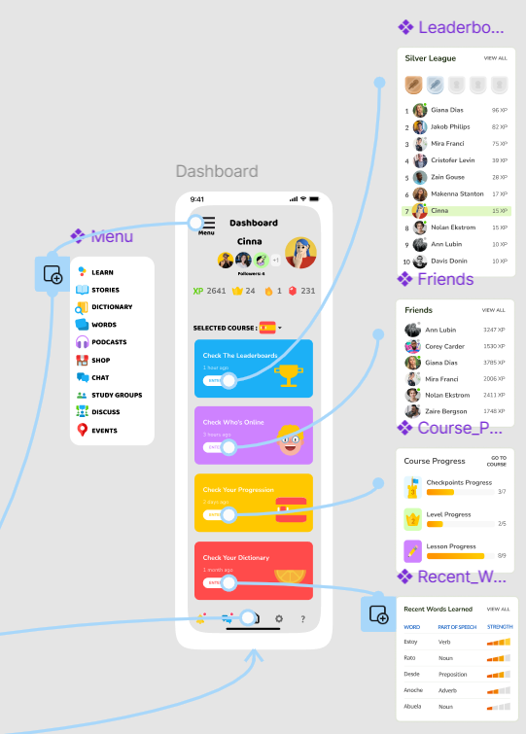

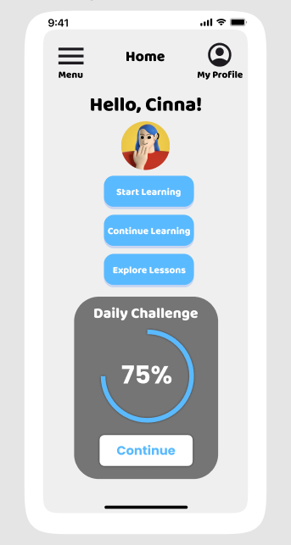

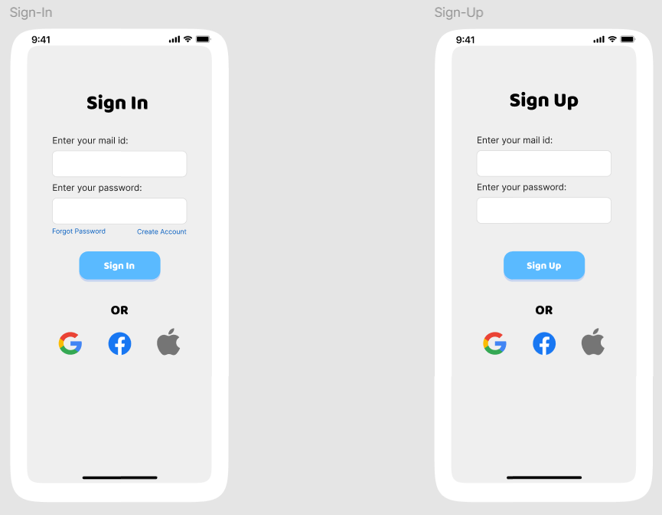

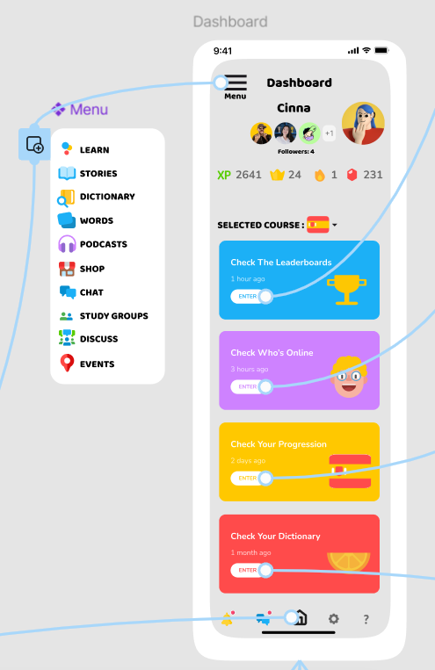

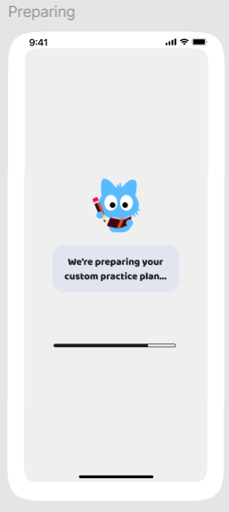

**______________________________________________________________________________**

**Outcomes: Apply principles of Web interface design**

**______________________________________________________________________________**

**Conclusion: (Conclusion to be based on the objectives and outcomes achieved)**

This experiment successfully demonstrated the application of mobile UI design principles through the creation of wireframes. By using consistent templates and appropriate composition patterns, we enhanced usability and user experience. The wireframes effectively organize information hierarchically, promoting learnability and reducing errors. Overall, the exercise highlighted the importance of user-centric design in mobile applications.

_______________**_______________________________________________________________**

**Grade: AA / AB / BB / BC / CC / CD /DD**

**Signature of faculty in-charge with date**

**______________________________________________________________________________**

**References:**

1. Wilbert O. Galitz, “The Essential Guide to User Interface Design - An Introduction to GUI Design Principles and Techniques”, Wiley Computer Publishing, Second Edition, 2002
2. Steven Hoober, Eric Berkman, “Designing Mobile Interfaces: Patterns for Interaction Design”, O’rielly Media, First Edition, 2012
3. http://4ourth.com/wiki/Composition

**______________________________________________________________________________**